3MTT Darey.io NextGen Cohort
Software Quality Assurance Project Assignment
Bug Report: Broken Submit Button on Sign-Up Page
Bug ID:
BUG-001
Title:
Submit Button Not Responding on Sign-Up Page
Application:
TechSphere Solutions – Sign-Up Page
URL Tested:
https://opensource-demo.orangehrmlive.com/
Reported By: NLIAM STANLEY
QA Tester
Date Reported:
19/06/2026
Description:
Users are unable to complete the sign-up process because the Submit button on the sign-up form does not respond after clicking. Some users reported that the button appears clickable but no action occurs, while others reported that no error message is displayed.
This prevents new users from creating an account successfully.
Environment:
- Browser: Google Chrome Version 115
- Operating System: Windows 11
- Device: Laptop/Desktop Computer
- Network: Stable Internet Connection
Severity:
High
Reason:
The issue blocks users from completing registration. It affects a major application function and prevents new users from accessing the system.
Priority:
High
Reason:
The issue requires urgent attention because user registration is a critical feature and should be fixed before release.
Preconditions:
- User is on the sign-up/registration page.
- User has a valid internet connection.
- Required form fields are available.
Steps to Reproduce:
- Open the sign-up page.
- Enter valid information into all required fields.
- Scroll to the Submit button.
- Click the Submit button.
- Observe the page response.
Expected Result:
After clicking the Submit button:
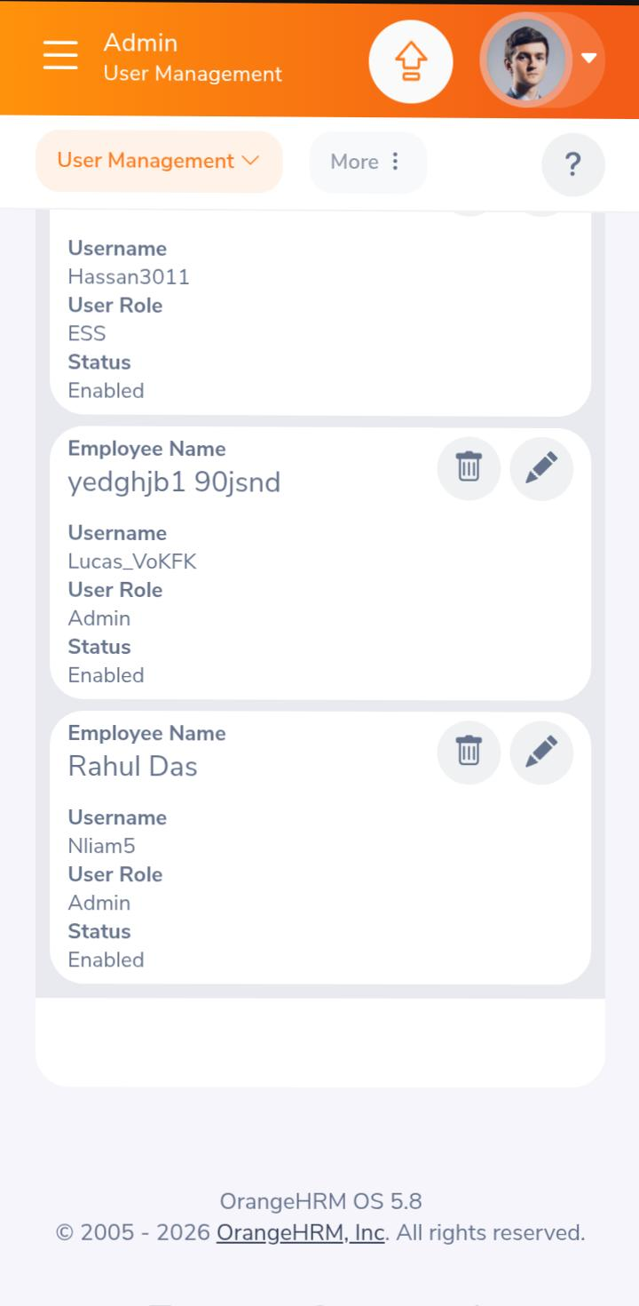
- The form should be submitted successfully.
- A confirmation message should appear.
- The user should be redirected to the next page or dashboard.
Actual Result:
- The Submit button does not respond after clicking.
- No confirmation message appears.
- No error message is displayed.
- User remains on the same page and cannot complete registration.
Reproducibility:
Frequency: 5/5 attempts
The issue occurs every time the Submit button is clicked.
Impact:
- New users cannot create accounts.
- Registration process is blocked.
- Customer experience is negatively affected.
- Potential loss of new users.
Attachments:
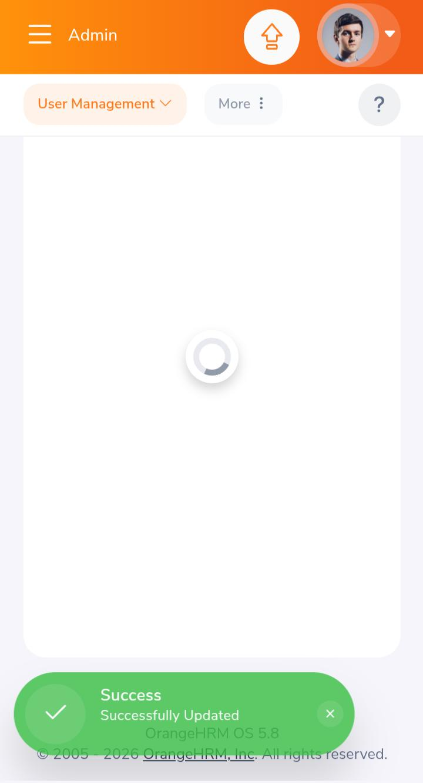
- Screenshot of the sign-up page showing the Submit button.
- Screen recording showing the button click with no response.
- Browser console error logs (if available).
Status:
Open – Assigned to Development Team
Recommendation:
Developers should inspect the Submit button functionality, form validation logic, and backend connection to ensure the registration request is triggered correctly.

